Coordination of the National Information System Statistical and Geographic
Country
Mexico

Type NIA-instrument
S1. Establishment of coordinating functions or entities

Aim
Establish the participation, organization, scope and responsibilities of the actors involved in the generation, acquisition, integration, process, distribution and conservation of information and statistics and geography, which supports the national development.

NIA-instrument description
The National Information System Statistical and Geographic is defined as the set of State Entities organized through Subsystems, coordinated by INEGI and articulated by the National Information Network, in order to produce and disseminate Information of National Interest.
SAMPLE GOOD PRACTICE
The System is composed by the National Advisory, the National Information Subsystems and INEGI Council as the coordinating agency. The latter directed by a Governing Board (consisting of a President and four Vice-Presidents).
The National Information Subsystems (currently: Demographic and Social, Economic, Geographic and Environment, as well as, government, public security and justice administration) aim to produce, integrate and disseminate information according to their theme(s). The Subsystems have several Specialized Technical Committees (CTE) coordinated by an Executive Committee Subsystem.
The CTE act as collegiate bodies of participation and consulting created by agreement of the Governing Board of the INEGI to support the National Information Subsystem to which they are attached; in these participate the so-called “Units of the State”, which are administrative areas that have the power to develop and Statistical and Geographic Activities or operate with administrative records to obtain information of National Interest:
a) The agencies of the Federal Government, including those of the Republic Presidency and the Attorney General's Office;
b) The legislative and judicial branches of the Federation;
c) The states and municipalities;
d) The autonomous constitutional bodies, and
e) The federal administrative court.
Such Units of State participate -in the scope of its powers- in the System through the National Advisory Council, Executive Committees and CTE in the definition, development and promotion of implementation of technical standards, indicators, and information of national interest methodologies used to generate the information, taking into account national and international standards and best practices in the field.
Likewise, at state level, creating committees of Statistics and Geographical Information as bodies that allow for greater coordination among agencies generators and users of information at different levels of government, academia and the private initiative, promotes in order to have quality information, relevant, accurate and timely systemically.
SAMPLE GOOD PRACTICE
Background
The National Information System Statistical and Geographic is endorsed by Article 26, subsection B of the Political Constitution of the United Mexican States.

Use
The participation in the System of the Units of the State, identified as such in the country, is given through the organs of competence and consultation defined by the Law, such as National Advisory Council, Executive Committees and CTE.

Good practice motivation
The definition and implementation of the system's participation and consultation bodies are considered good practice in relation to NIA, since they establish the cooperation links that contribute to inter-institutional coordination and the implementation of policies, plans and strategies for The performance of the statistical and geographical activities of the country.

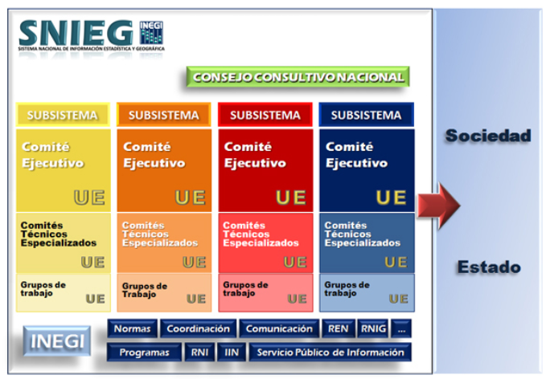
Figure: National Information System Statistical and Geographic
Official website of the National Statistical and Geographic Information System (SNIEG): http://www.snieg.mx

Reference

Official website of the National Statistical and Geographic Information System (SNIEG): http://www.snieg.mx

Rating according to their level of application (1..10), a value of 10 means that it has a strong level of application.
SAMPLE GOOD PRACTICE
1 |  | 2 |  | 3 |  | 4 |  | 5 |  | 6 |  | 7 |  | 8 |  | 9 |  | 10 | X
Less application ………………………………………………… Strong application

